Rang 5 - Work Assignments for 30th March – 3rd April
The following work is set as a plan to support parents and children in these difficult times. Parents may decide to some or all of it, depending on their circumstances. It cannot be emphasised enough that children do not need undue pressure in their homes at this time, but some parents may want to give regular work to their children.
With this in mind, we have chosen work that should be manageable for all students.While we are including links to internet sites, we understand that some students may have difficulty with internet access. They are offered as support, but are not essential.
TadhgO’Riordan& Valerie Barry.

Maths: (Answer Sheets also attached)
- Master Maths: Week 27 (ignore any sums that are too difficult as we do not have all
topics covered yet)
- Busy at Maths
- Chapter 23: Directed Numbers Pg 125 & 127 (Pg128 is a bit challenging but can be
attempted by those who can manage it)
- Chapter 25: Weight Pg 135 & 136(similar principals are used in the topic Length, which has already been covered so this should not cause too many problems, but again, ignore any sums that you cannot do)

Remember that Maths iPad apps like Numbler and MathFight can be a fun way to revise your tables while playing with your siblings/parents.

English:
- Reading: Up & Running ‘Wilbur’s Boast’ Pg. 218 – 228 ‘Write down new words in your copy and put them into sentences orally.
There are trigger questions and prompts available at the following link if required for the Flights of Fancy activity.
http://data.cjfallon.ie/wonderland/stages3and4/S4_B1_C17_E2.html
Vocabulary Work – children can explore meaning of new vocabulary from the story using the following link.
http://data.cjfallon.ie/wonderland/stages3and4/S4_B1_C17_E1.html

- Writing:Activities Pg. 230 & 231.
- Spellings: Spell Well Week 23. Check the meaning of all words before you attempt to do the written exercises
You can use your computer / tablet to access ‘Spelling City’ online.
The address is www.spellingcity.com/valbarry
- It should open as Valerie Barry’s Lists
- Scroll down to Spell Well 5 (Wk 23) and click Games.
- Select Free Activities
There are several word & spelling games to help you learn and test your spellings
in a fun way.
- Read your Novel each day. (Write down 3 main points from each chapter and check
new words in your dictionary.

Gaeilge:
- AbairLiom p.86 read the story Feisteas
- AbairLiom p.81 read the fógra
- AbairLiom p.80 read the vocabulary on the poster, play Bingo with someone at home or practice using them in sentences.
- Spellings – Revise spellings we have marked on the Éadaí spelling sheet.

Busy at Maths 5 Answers
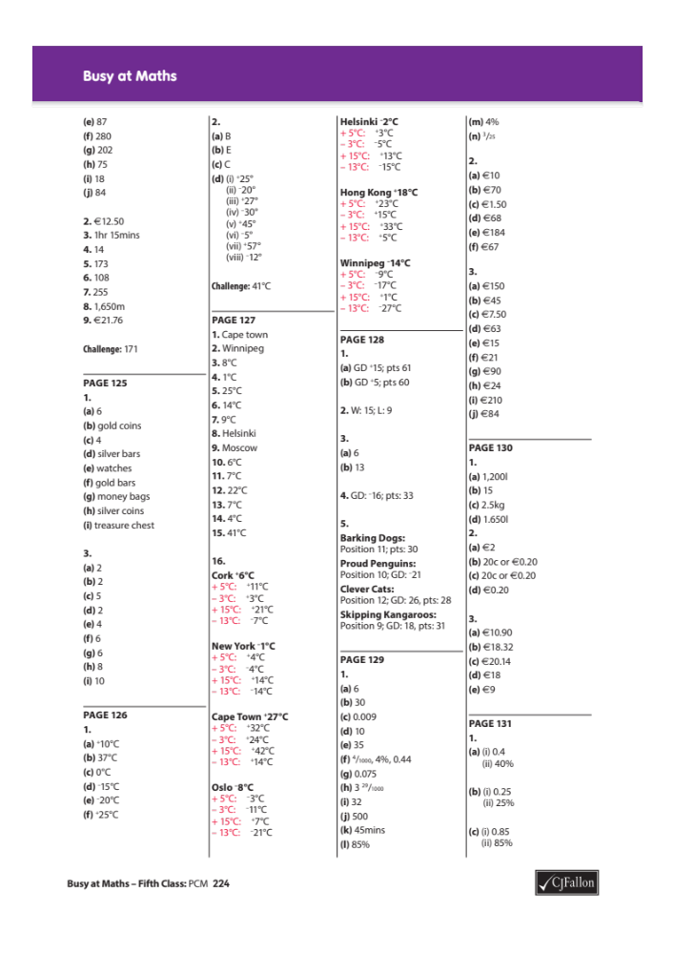

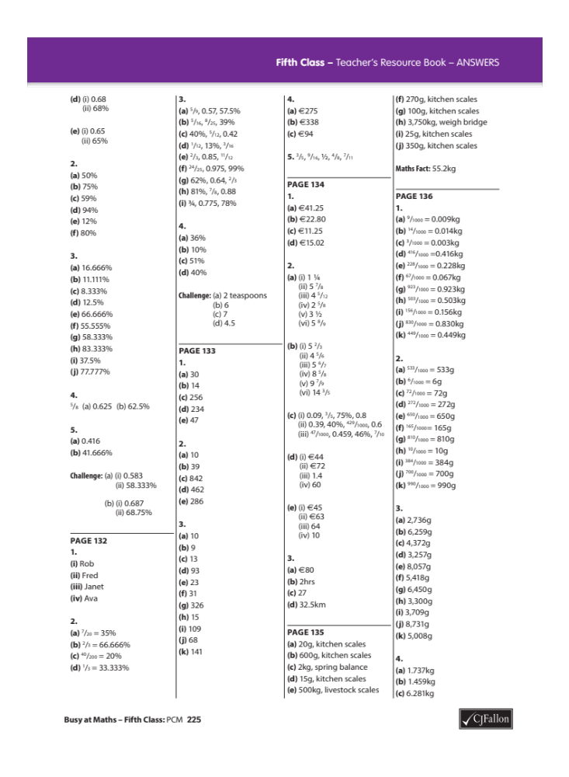

Master Your Maths 5 Answers
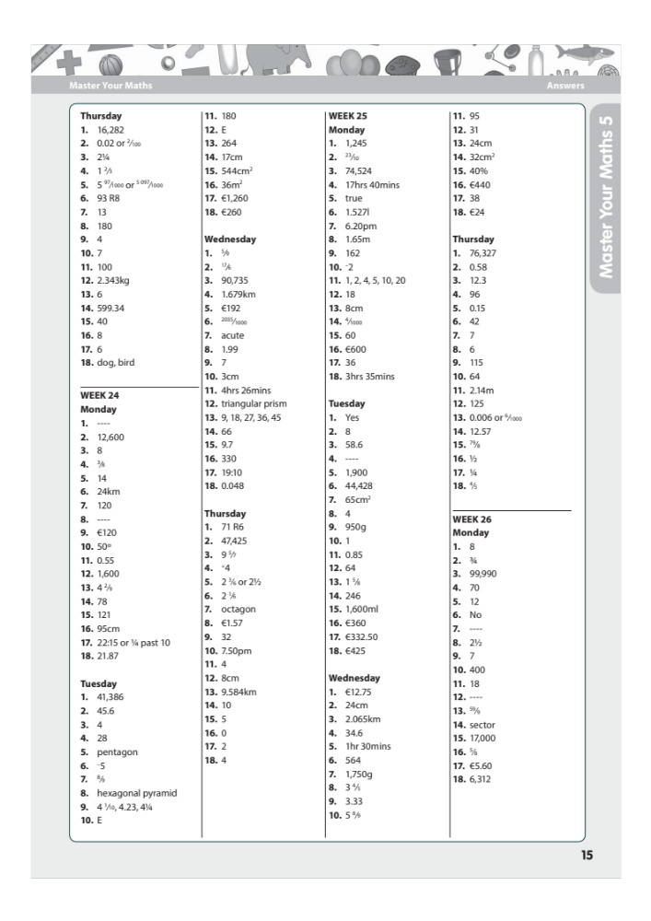

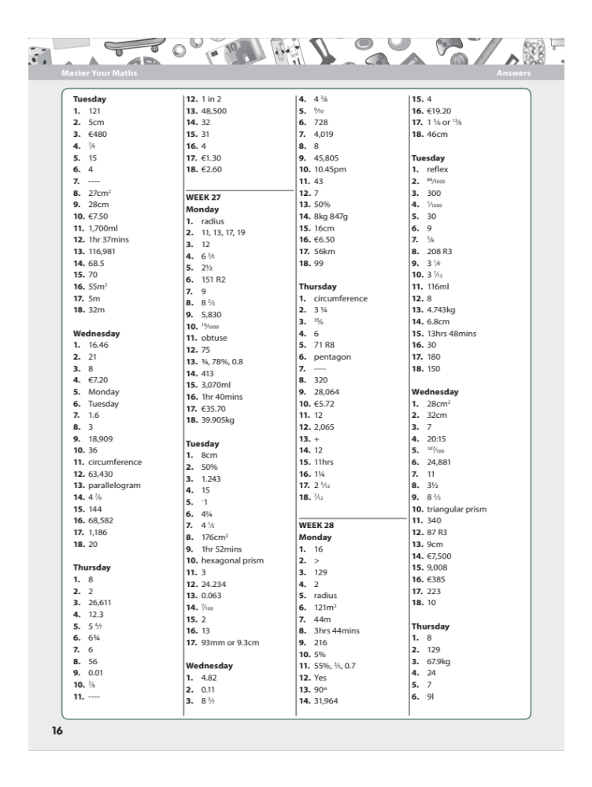

Master Your Maths 5 Test Answers


