Please Note

**Please click download when viewing this on a mobile device otherwise you cannot view it correctly**
It is best downloaded on a computer if printing worksheets but if you click download and not view on a mobile device then the layout should be ok.

Dear Parents,
Below is a little day by day outline of work for the children. I can’t stress enough that these are all suggested activities. I know I have far too much but I wanted to give you plenty of ideas and options. NONE of the work is compulsory but if you are doing any work try to do some work in their text books and their sound of the week. The worksheets included below are for any eager beavers! I know it looks like I have loads but honestly it’s just ideas and maybe it is better to be looking at it than for it or trying to come up with work yourself when I know everyone has enough to be doing.
I know there is a lot of information out there at the moment recommending apps & books etc for children but there are 2 programmes I think would be very beneficial for your child they are Sounds Like Phonics and Bua na Cainte
I have outlined how to access these below. If for any reason you need help please contact the school email and I will get in touch with any support you need asap.
For their literacy I will be referring to the book Sounds Like Phonics a lot. (https://slp.cjfallon.ie/) If the link won’t work type ‘Sounds Like Phonics Online’ into Google, click on Activity Book A, then click unit 4 for our sound of the week which is z this week. The children will be familiar with the activities here and they will really help you when approaching a new sound with your child.
I have included a template for the upcoming sounds. Print these out if you can and add them to their sound folder as we cover them. I know I gave you (ie, ee & or sounds) but I will actually leave these for now as they are tricky.
If you want to do some Gaeilge then I recommend you download Bua na Cainte. Unfortunately this has to be downloaded onto a laptop. It is the programme we use in class. The children have covered Mé Féin, An Scoil, Bia, Caitheamh Aimsire, An Aimsir and Éadaí so stick with these. The children really enjoy Bua and they wouldn’t require a lot of help once they are set up. In Ócáidí Speisialta click An Cháisc for 2 lessons and a Rainn for them about Easter. If you don’t have a laptop check out Abair Liom A on the Folens website. Claire sent details of how to access this. To download Bua na Cainte click this link http://edco.ie/buaA Username: Trial Password: trial
Hope this finds you all well. As I have said before everyone’s health is the number one priority at the moment. Anything I have included here is honestly just to try and help you out not stress you out! Take care, Síle.


Note for Children

Hi boys and girls I hope you are all having a great time at home with your family! I have been hearing about all the amazing things you have been doing to help out at home.
I have sent some work for you to do this week. There is a new sound in there and I have told your parents about our crazy stir-fry song. Please sing it for them they will love it as much as I do. I wonder would your family be able to say some words in the song beginning with your new sound z. Here is a z tongue twister for you to try
Zizzi’s zippy zipper zips. Here you can listen to all our songs and actions for our sounds. Some of the sounds you won’t know yet but that is ok. https://www.youtube.com/watch?v=xzBoqtayewI

I hope you have all been doing lots of reading, colouring, writing and playing when the grownups ask you to. I can’t wait to see all your hard work!

Freddy had been keeping very busy at my house. Yesterday he painted the spare bedroom and cut the grass. He is so helpful! He has also been doing lots of songs from the learning station like the Hello Song and Shake your Sillies out.
He has been doing his sounds too. Sometimes he finds his writing hard but he has been trying his best.
Mary said to tell you all she really misses you and she hopes you are all still eating all that delicious fruit especially Granny Smith, Pink ladies, Golden Delicious and Red Ninjas!

I miss you all and I am looking forward to seeing you all soon.

Bye for now,
Ms. Canniffe ☺

Monday
Literacy:  - Phonics:  Daily routine for phonics:  - Introduce the z sound using Sounds Like Phonics link https://slp.cjfallon.ie/  - Play this song (Crazy Stirfry) and get your child to say words beginning with z when the music goes silent. They will be used to this! (I hope!!)  - Worksheet Number 2  - Reading:  - Read up to the stars Week 3 Monday  - Read GG is Too Big pg 2- 4.  - Writing  - Mrs Murphy (green copy) Do page 3 letter a. (around like a c, up down and a flick) | Maths:  Worksheet Number 1  Focus on the number 5 this week.  Ideas:  Ask your child to make a set of 5 objects.  Ask them to count them out loud.  Discuss the story of 5 Activities here.  4 and 1 make five, 1 and 4 make 5, 2 and 3 make 5 etc use lego/cubes to represent these.
Grow in Love:
Pg 36 – 41 are based on Easter feel free to let the children do these pages and chat to them about them in the run up to Easter. (If you want)
Lovely Online Resources inc stories they can watch:
www.growinlove.ie
email:trial@growinlove.ie
password: growinlove

Tuesday
Literacy:  - Phonics:  Daily routine for phonics: (see Monday)  - Worksheet Number 3  Idea: Play z matching game (see below)  - Reading:  - Read up to the stars Week 3 Tuesday  - Read GG is Too Big pg 5- 7.  - Writing  - Just Write pg 30 | Maths:  Planet Maths pg 82.  Ideas:  Print and play number matching game (at very end of document)  Suggested activities below for working towards numbers up to 5

Wednesday
Literacy:  - Phonics:  Daily routine for phonics: (see Monday)  - Worksheet Number 4  - Reading:  - Read up to the stars Week 3 Wednesday  - Read GG is Too Big pg 8 - 10.  - Writing  - Mrs Murphy (green copy) Do page 4 letter d. (around like a c, up high, down and a flick) | Maths:  Planet Maths Number Practice Book.  We skipped pages in this book. The aim this week is to try and do any pages your child missed stopping at page 5.

Thursday
Literacy:  - Phonics:  Daily routine for phonics  - Worksheet Number 5  - Reading:  - Read up to the stars Week 3 Thursday  - Read GG is Too Big pg 11 - 13.  - Writing  - Purple copy. Sample below. Write the letter z. Draw pictures at the top of things that begin with z. | Maths:  Worksheet Number 6

Friday
Literacy:  - Phonics:  Daily routine for phonics:  - Worksheet Number 7  - Reading:  - Read up to the stars Week 3 Friday  - Read GG is Too Big pg 14 - 16. | Maths: (15mins)  Planet Maths pg 83.
- Writing
Free writing on scrap paper. Get them to practise writing z and as many words they can write. Let them copy words from Read up to the Stars. We always write as many letters, numbers and words as we can on the back of any worksheets they do. They love the sense of achievement. Writing their Read up to the stars words are great ways to practise their writing everyday if they want.

****NB Only add z to their sound folder this week****
z | w
v | y
x | ch

Worksheet 1 Monday
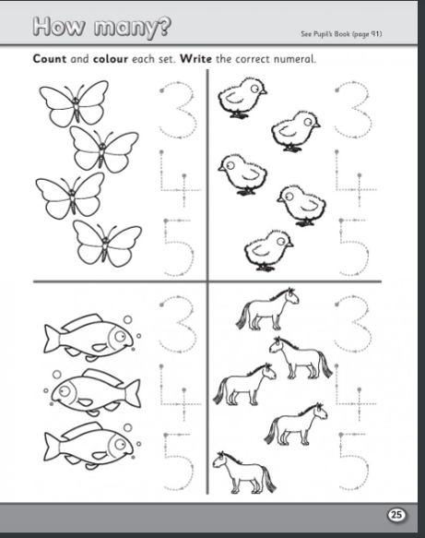

Worksheet 2 Monday
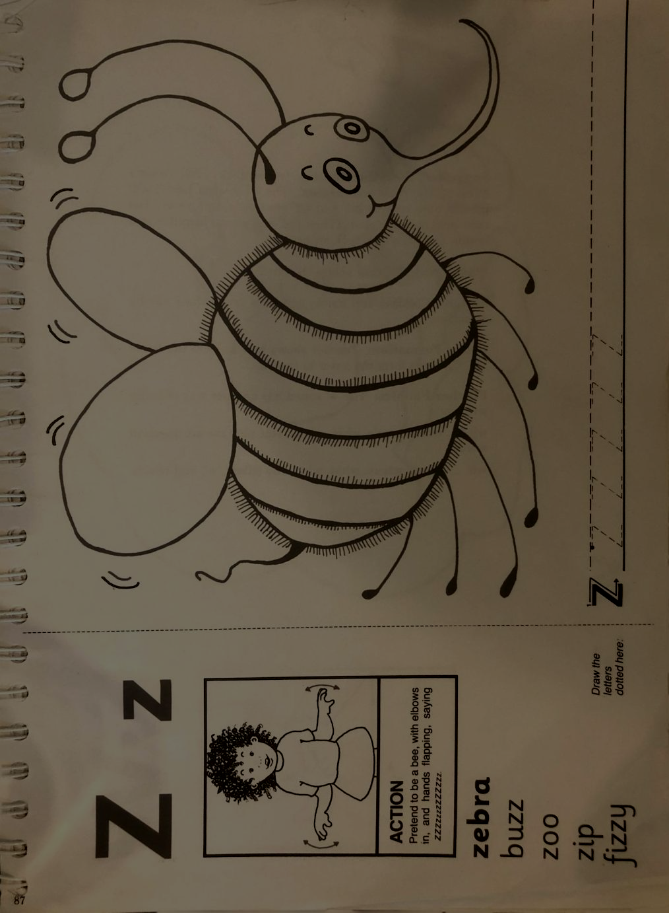

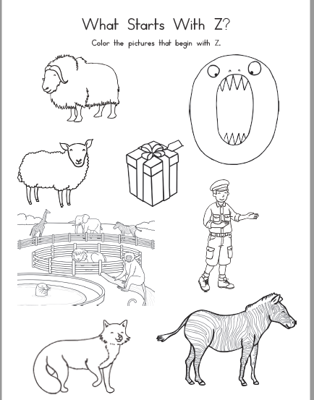
Worksheet 3 Tuesday

Worksheet 4 Wednesday
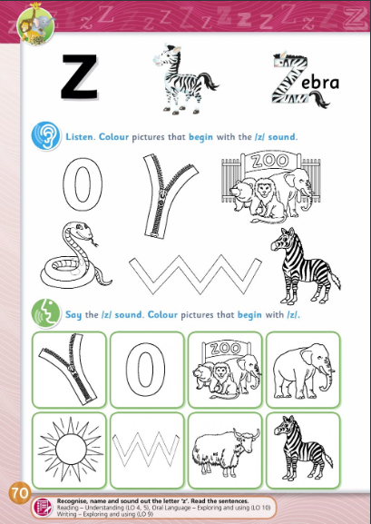

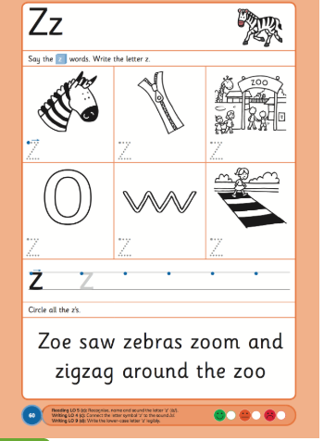
Worksheet 5 Thursday

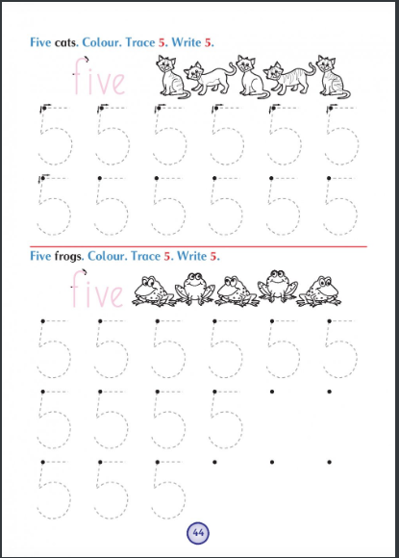
Worksheet 6 Thursday

Sample of Purple Copy Work
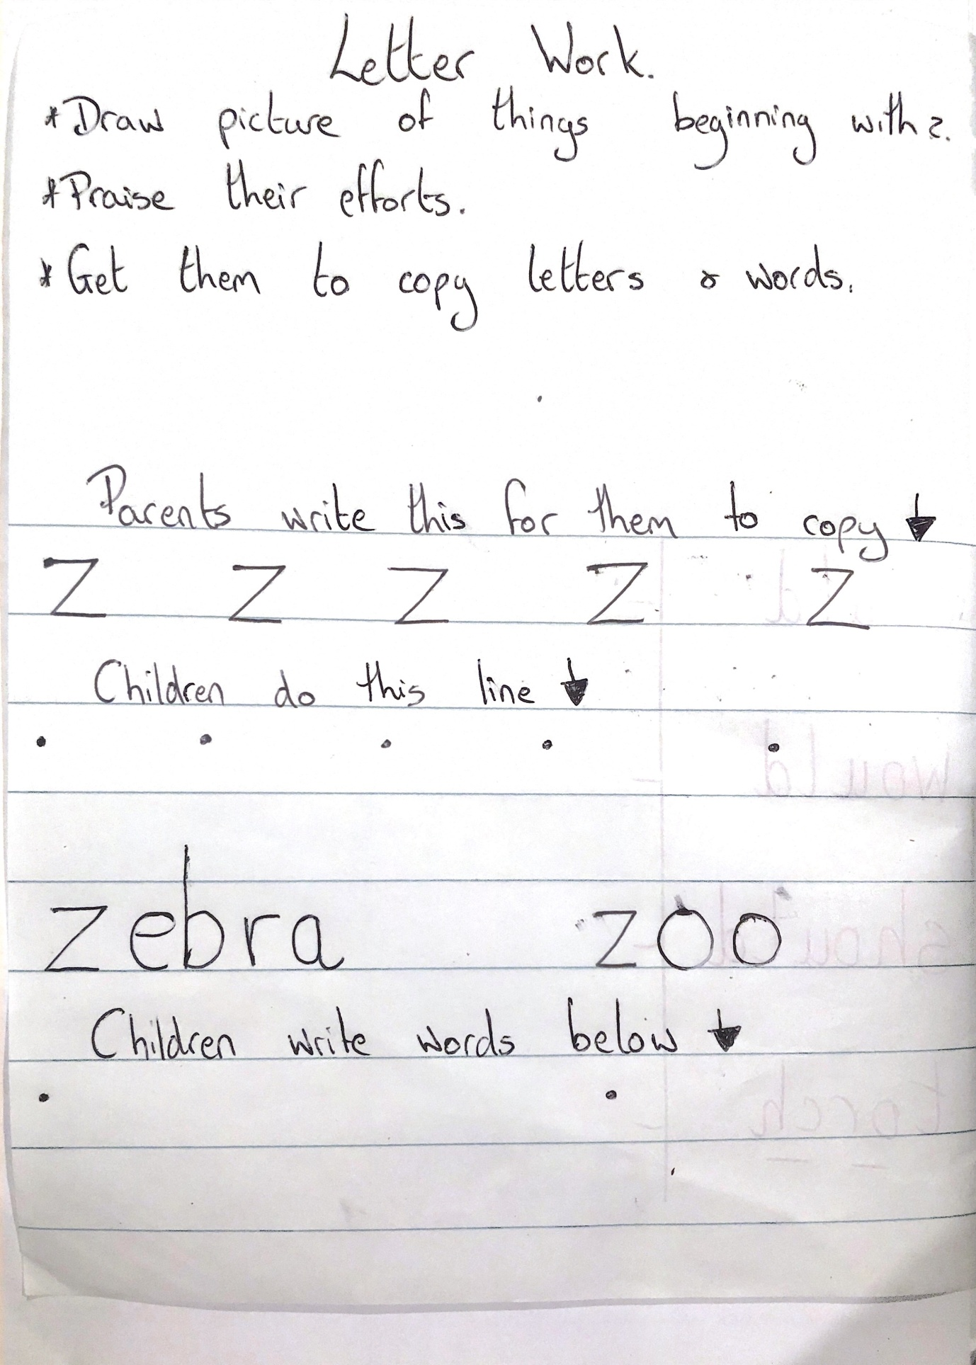

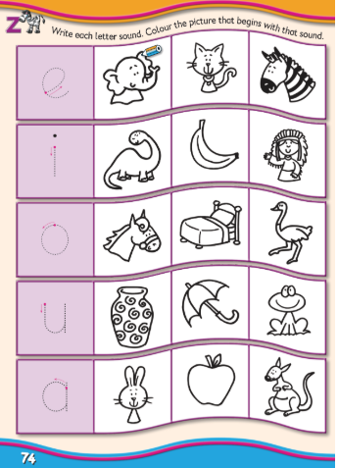
Worksheet 7 Friday

Z Matching Game
Print these turn them upside down and play z matching game. Get your child to cut them out to work on their cutting skills.
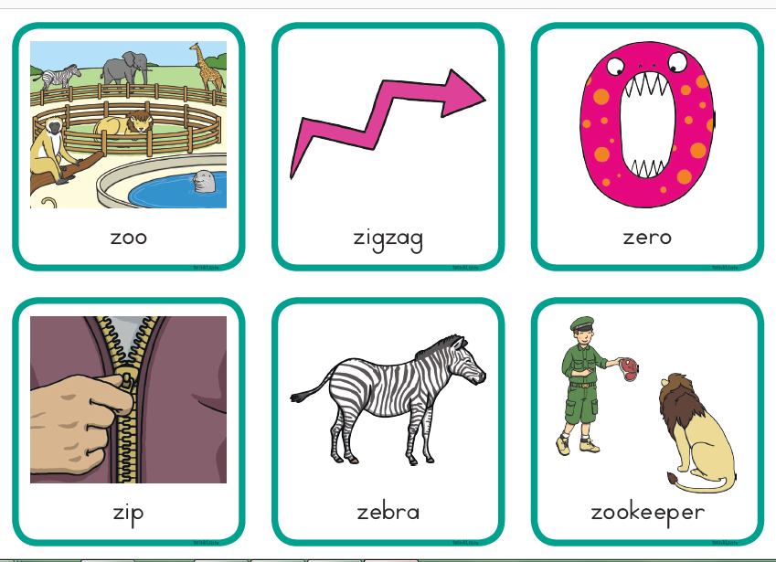

Number Matching Game
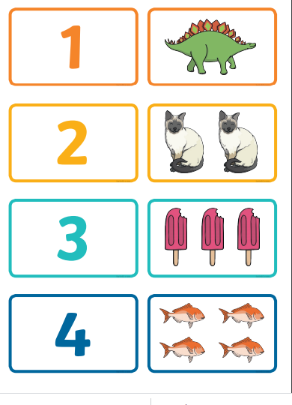
Print these turn them upside down and play z matching game. Get your child to cut them out to work on their cutting skills.
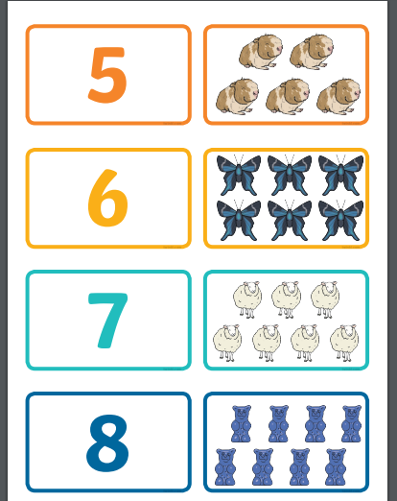

Ideas for the number 5
(zoom in to read them or make them bigger yourself. I was just trying to reduce pages)



