Rang 6 - Work Assignments for 30th March – 3rd April

The following work is set as a plan to supportparents and children in these difficult times. Parents may decide to dosome or all of it, depending on their circumstances. It cannot be emphasised enough that children do not need undue pressure in their homes at this time, but some parents may want to give regular work to their children.
With this in mind, we have chosen work that should be manageable for all students.
If you feel that there is not sufficient work included, please let us know so that we can add more to the list in the upcoming weeks. While we are including links to internet sites, we understand that some students may have difficulty with internet access. They are offered as support, but are not essential.
We send our kind regards and fond wishes to pupils and their families and look forward to seeing you all back in the ScoilBhríde community very soon.

Anna Walsh & Valerie Barry.

Maths: (Answer Sheets also attached)
- Master Maths: Week 27
- Busy at Maths Chapter 31: Weight (similar principals are used in the topic Length, which has already been covered so this should not cause too many problems
Pg 162 – 164
Pg 165 is optional as it is more difficult.
Pg 166 & 167 arechallenge pages for those who wish to do them.

Remember that Maths iPad apps like Numbler and MathFight can be a fun way to revise your tables while playing with your siblings/parents.

English:
- Reading: Racing Ahead Pg. 232 – 235 ‘The Hands that Built America’.
Write down new words in your copy and put them into sentences orally.
- Writing: Activities Pg. 236 & 237.
There are trigger questions and prompts available at the following link if required for the Flights of Fancy activity.
http://data.cjfallon.ie/wonderland/stages3and4/S4_B2_C18_E2.html

Vocabulary Work – children can explore meaning of new vocabulary from the story using the following link.
http://data.cjfallon.ie/wonderland/stages3and4/S4_B2_C18_E1.html
- Spellings: Spell Well Week 27. Check the meaning of all words before you attempt to do the written exercises.
You can use your computer / tablet to access ‘Spelling City’ online.
The address is www.spellingcity.com/valbarry
- It should open on Valerie Barry’s Lists
- Choose Spell Well 6 (Wk 27) and go to Games.
- Select Free Activities
There are several word & spelling games to help you learn and test your spellings in a fun way.
- Read your Novel each day. (Write down 3 main points from each chapter and check new words in your dictionary.)

Please put the Class Novel “Hitler’s Canary” in a safe place if you have finished reading it as I need to return them when we go back to school!!Thank you.

5. Poetry

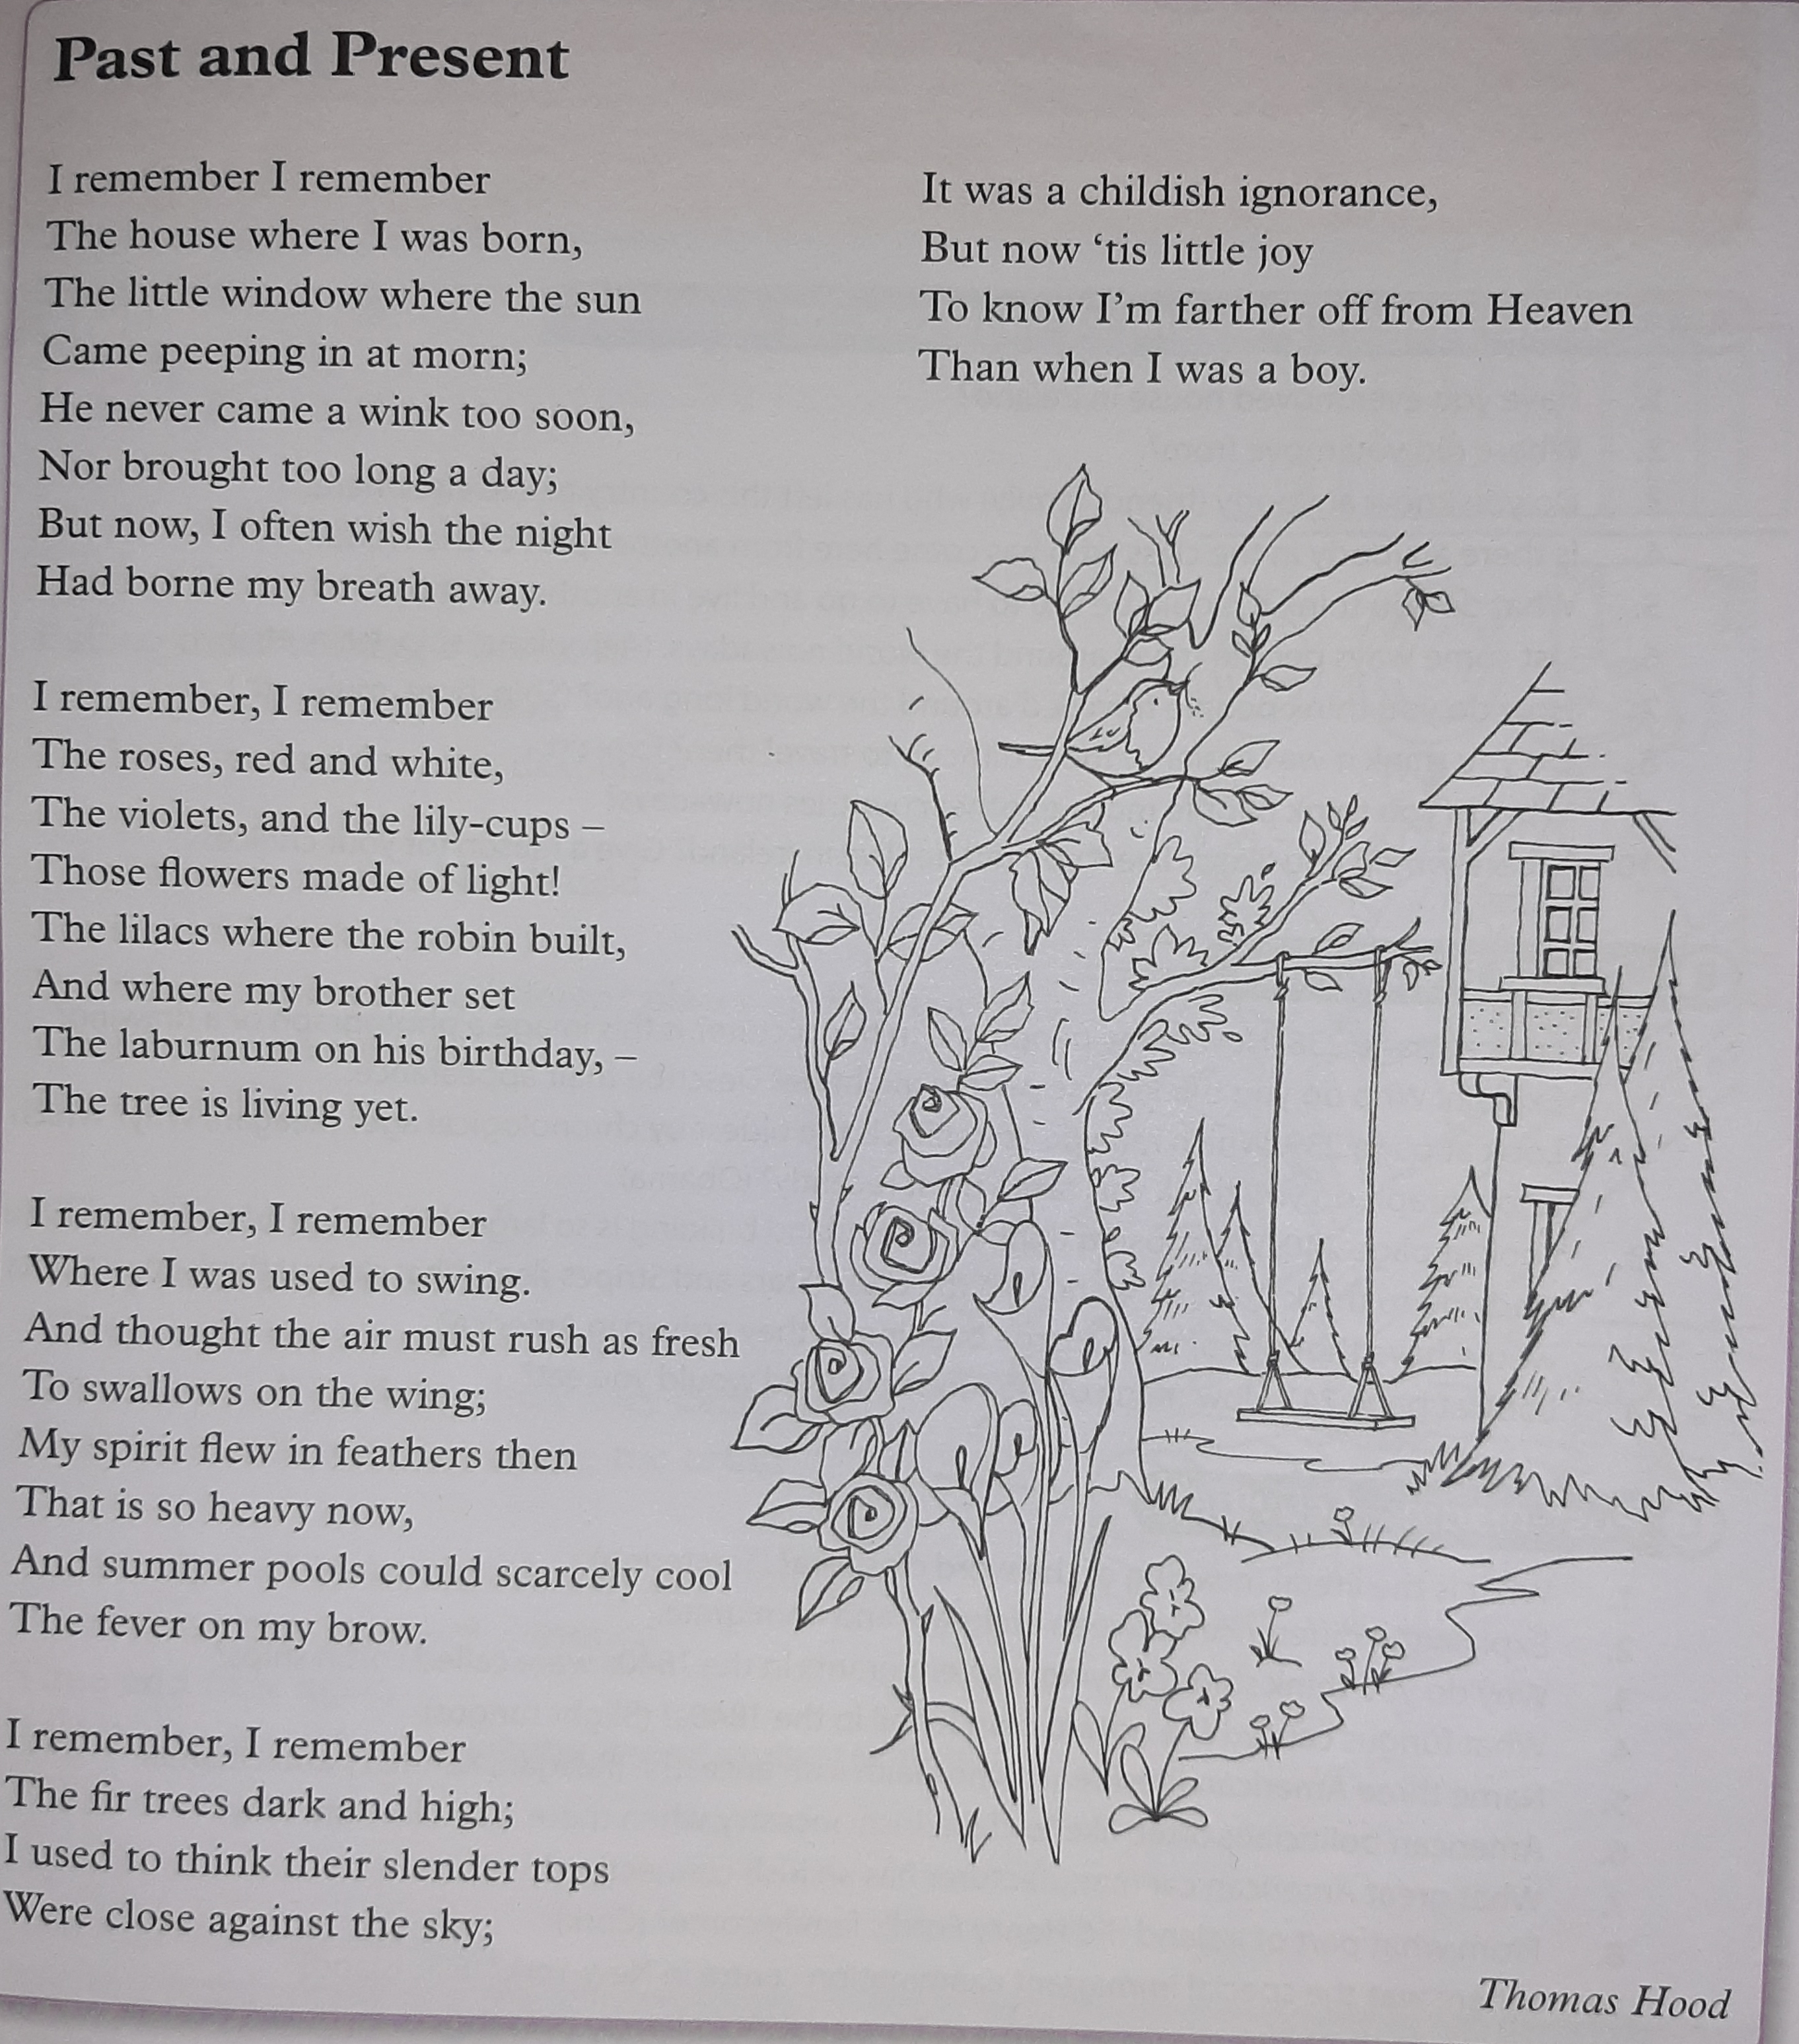

- What time in his life is the poet writing about?
- What line in verse 1 tells us that he would be happy to die?
- How do we know that the poet had an appreciation of nature?
- What line in stanza 2 conveys the lasting impact of nature?
- What do you think the poet means by the line “My spirit flew in feathers then”?

Gaeilge:
AbairLiom
Tubaistínádúrtha. p108 to 110(Natural disasters)

Foclóir:
Sraithtonnta= a series of waves
Is cúisleo = is the reason for
Lá an Dreoilín= St Stephens Day
Ó smacht= out of control
Is annamh= rarely
Anuraidh= last year
Dóiteánmórforaoise = big forest fire
Foirgneamh=buildings
Crithtalún = earthquake
An meánchiorcal = the equator
Bogadhtobann= sudden movement
Tuilte= floods

- Ceisteanna p.109

- Litriú- An dán “An Fear Bocht” arleathanach 111

- Scroibhneoireachtarleathanach112

https://my.cjfallon.ie/dashboard/student-resources
6th class ->Gaeilge ->LéighsaBhaile ->Leabhar F -> Page 80 and 81 agusnaceisteanna

History:
Small World CJ Fallon.
Unit 13 Mahatma Gandhi p.72 to p. 74
Activities p.75

Religion:
Grow in Love Theme 7 Holy Week and Easter

Lesson 1 - We Remember the Passion and Death of Jesus p.74 to 77
Lesson 2 - Easter: Our Reason to Hope p.78 to 81

Confirmation Workbook: (Use a Bible or Google)
The last Supper
Jesus is Crucified
Easter a time of new life

Songs to sing and dance to.....

- Dance Monkey – Tones And I
- Dancing Queen –Abba
- I Don’t Wanna Dance –Eddie Grant
- Let’s Dance- David Bowie
- Fame
- Jump- Van Halen
- The Blue Danube Waltz – Strauss (with a partner)
- Bohemian Rhapsody - Queen
- Don’t Stop me now-Queen
- From a Distance- Nancy Griffith
- We’ll meet again- Vera Lynn☺

Starting on RTÉ2 from Monday 30th of March – Home School Hub: 11:00am to 12:00pm
RTÉ Home School Extra: 4:15

Typing:
Typing will be a very important skill for all of you when you get to secondary school. This may be a good opportunity for you to learn the basics of touch-typing. These are some free websites for you to access if you wish to try. For those of you already set up with accounts on Typing Club, please continue to practice regularly (10-15 min/day)

http://www.typingclub.com

https://www.dancemattypingguide.com/dance-mat-typing-level-1/stage-1/

Busy at Maths 6 Answers
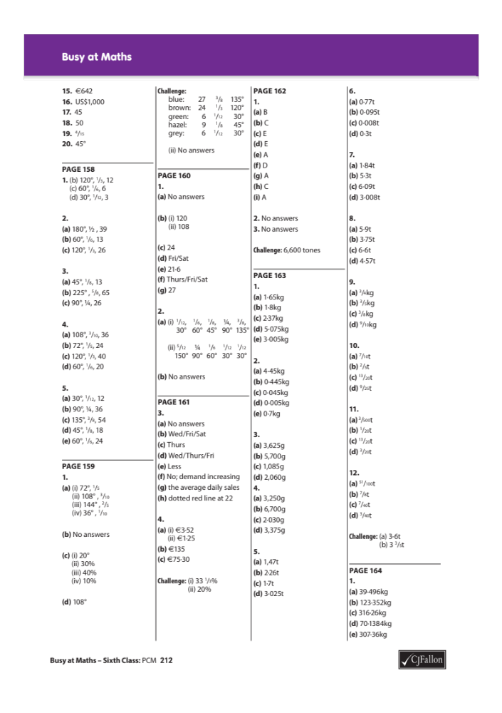

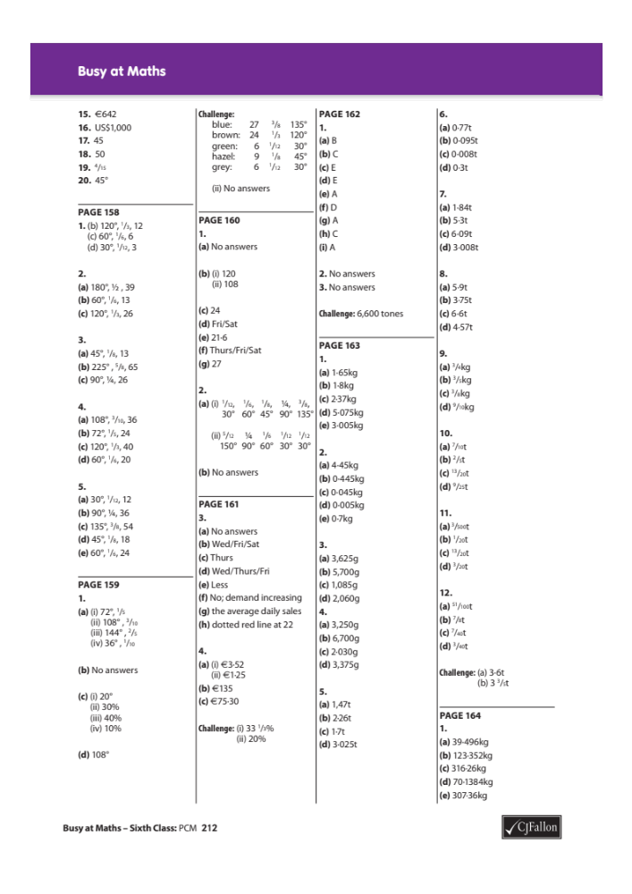

Master Your Maths 6 Answers
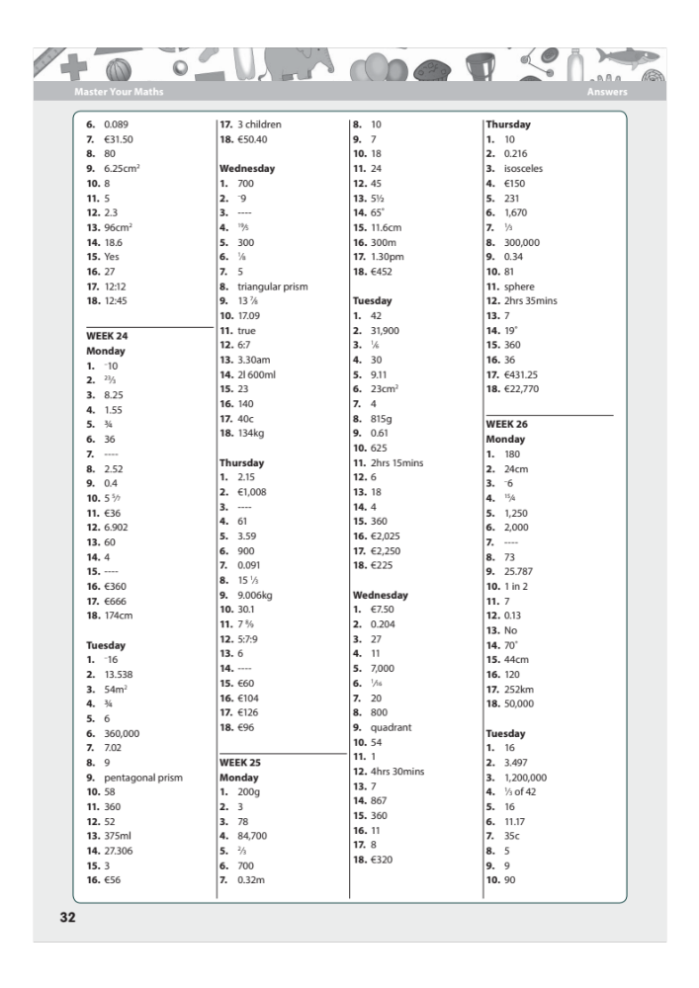

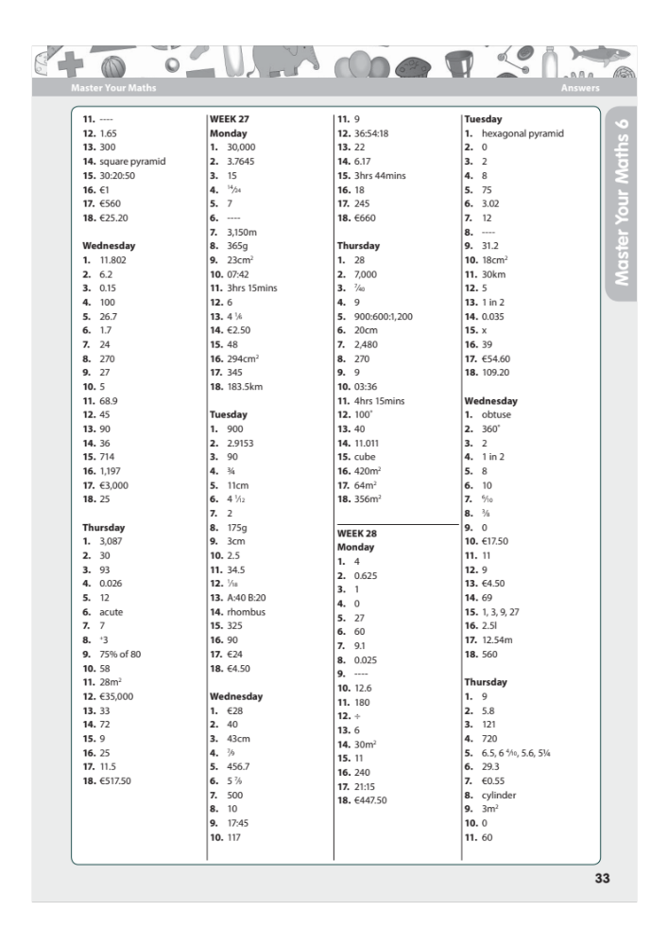

Master Your Maths 6 Test Answers


